**PERSONAL VOICE ASSISTANT**

**ARTIFICIAL INTELLIGENCE**

**Name : C.Omeswar Reddy &**

**S.Nagabrahma Chaitanya**

**Roll No : 50 & 67**

**Reg No : 11802308 & 11810677**

**Section : K18JC**

**Submitted to : Sagar Pande**

**Contents**

* **Introduction:**
* Aim and Purpose
* Scope
* Concept of Artificial Personal Assistant
* **Hardware and Software Requirements:**
* Hardware components
* Software Components
* **Working of an Artificial Personal Assistant:**
* Working and its layers
* **Available Applications Globally:**
* Comparisions
* **Features of Personal Assistant**
* **User Interface**
* **Advantages and disadvantages of Personal Assistant**
* **Personal Voice Assistants in future**
* **Conclusion**

**Introduction :**

Voice assistants are software agents that can interpret human speech and respond via synthesized voices. Apple’s Siri, Amazon’s Alexa, Microsoft’s Cortana, and Google’s Assistant are the most popular voice assistants and are embedded in smartphones or dedicated home speakers. Users can ask their assistants questions, control home automation devices and media playback via voice, and manage other basic tasks such as email, to-do lists, and calendars with verbal commands. This column will explore the basic workings and common features of today’s voice assistants. It will also discuss some of the privacy and security issues inherent to voice assistants and some potential future uses for these devices. As voice assistants become more widely used, librarians will want to be familiar with their operation and perhaps consider them as a means to deliver library services and materials.

**Aim and Purpose:**

The aim of the project is to provide personal assistant using voice recognition or text mode operation. This program includes the functions and services of : calling services, text message transformation, mail exchange, alarm, event handler, location services in mobile phone and music player service, checking weather, Google searching engine, Wikipedia searching engine, camera, Bluetooth headset support, help menu and video player etc in personal computer.

As it integrates most of the mobile phone services for daily use, it could be useful for getting a more convenient life and it will be helpful for those people who have disabilities for manual operations. This is also part of the reason why it has been chosen as our project.

**What is personal voice assistant ?**

A **Personal Voice Assistant** is a software agent that can perform tasks or services for an individual based on commands or questions. Sometimes the term "**chatbot**" is used to refer to virtual assistants generally or specifically accessed by online chat. In some cases, online chat programs are exclusively for entertainment purposes. Some virtual assistants are able to interpret human speech and respond via synthesized voices. Users can ask their assistants questions, control home automation devices and media playback via voice, and manage other basic tasks such as email, to-do lists, and calendars with verbal commands. A similar concept, however with differences, lays under the dialogue systems**.**

**Scope:**

The scope of the project is to build a program that will be able to serve like a human personal assistant. This is an interesting concept and many people around the globe are working on it. Now-a-days time and security are the two main things to which people are more sensitive: Nobody has the time to get spoil and nobody would like their security on breach. And this project is mainly for those kinds of people.

**Concept of an Artificial Personal Assistant:**

Personal Assistant works on artificial intelligence which understands natural language voice commands and completes tasks for the user. The assistant that I designed works on the basis of source code python.

It is a voice-controlled personal digital assistant. We can control or done anything by our voice. This project is a combination of

* Automatic Speech Recognisation
* To understand user’s speech input.
* Artificial Intelligence
* To understand command according to user’s input.
* Natural Language Processing
* To learn things from the user and to store all information about the user behavior and relationship.
* Inter Process Commmunication
* To get important information from other software Applications.

**Hardware and Software Requirements :**

* **Hardware**
* A phone with a touchscreen interface
* Phone ram should be minimum of 1GB
* Connectivity of internet
* Mobile phone should have USB debugging mode for development and testing purposes.
* **Software**
* Operating system should be above android 5 or windows 8.1 or IOS 6
* The kernel system should be greater than3.0.16
* Some other applications support like maps, calendar, camera etc

**Working of Personal Assistant :**

Any Personal Assistant basically consists of three layers. They are

1. Speech to text
2. Text Analysing
3. Interpret commands
4. **Speech to text**

* A piece of software is used that converts audio to text.

It doesn’t understand just anything you said

1. **Text Analysing**

* Converted letters is just letters for computer
* A piece of software converts text to something that is understandable for computer
* Computer understands the command, so Virtual Assistant like cortona converts text to computer command.
* Personal Assistants maps the words to functions and parameters to create a command that can be understandable by the computer.

Example: Reminder of any event

1. **Interpert commands**

* In this layer the mapped computer commands go to the server through internet.
* At the same time the speech will be evaluated locally.
* A local recognizer communicate with the server to judge whether commands will be best handles locally or not.

Example: Play music, Locate a place etc

**Available Applications :**

There are several Applications similar to our project artificial personal assistant. They work on their specific platforms for which they are made of. Spme of the VPAs are described below.

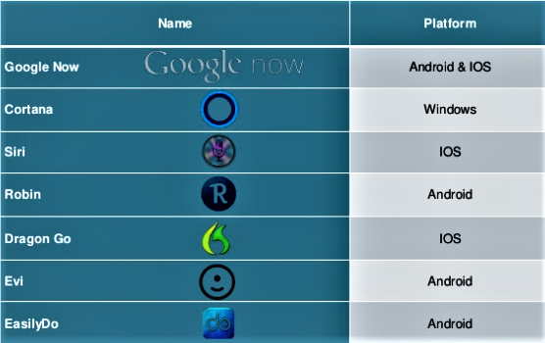

**Dom**-Dominos

**Sirius**-University of Michigan

**Sphinx**-CMU Sphinx

**Jarvis**-ItsMyLab

**Alice**-AIVC

**Robin**-Robin Labs

**Braina**-BrainaSoft

**Mycroft**-Mycroft

**SILVIA**-SILVIA

**Erica**-Bank Of America

**Siri**-Apple

**Alexa**-Amazon

**Watson**-IBM

**Bixby**-Samsung

**Viv**-Samsung

**Cortana**-Microsoft

**M**-Facebook

**Hound**-Houndify

**Star** (unofficial)-Starbucks

**Google Assistant**-Google

**Features of Personal Voice Assistant :**

Some features of personal assistant used in day by day in our daily life are as shown below.

* Make a Phone call
* Schedule meetings and appointments
* Get direction
* Send Messages
* Set Remainders
* Ask Questions
* Play Music and videos
* Wake up call

**User Interface :**

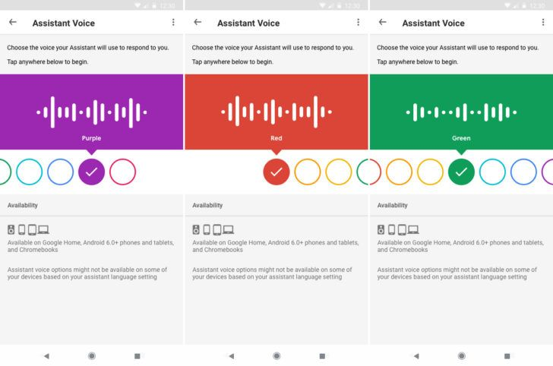

**Google Assistant**

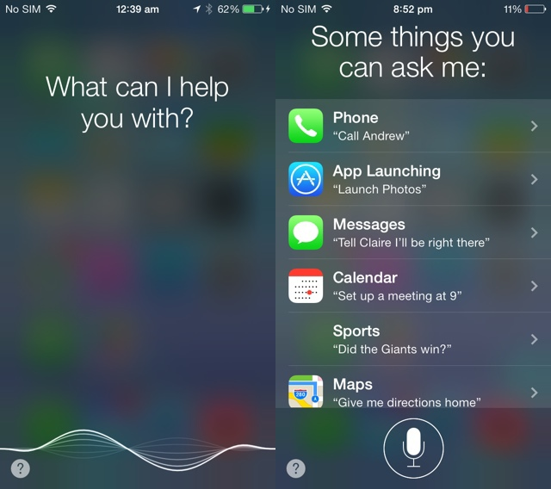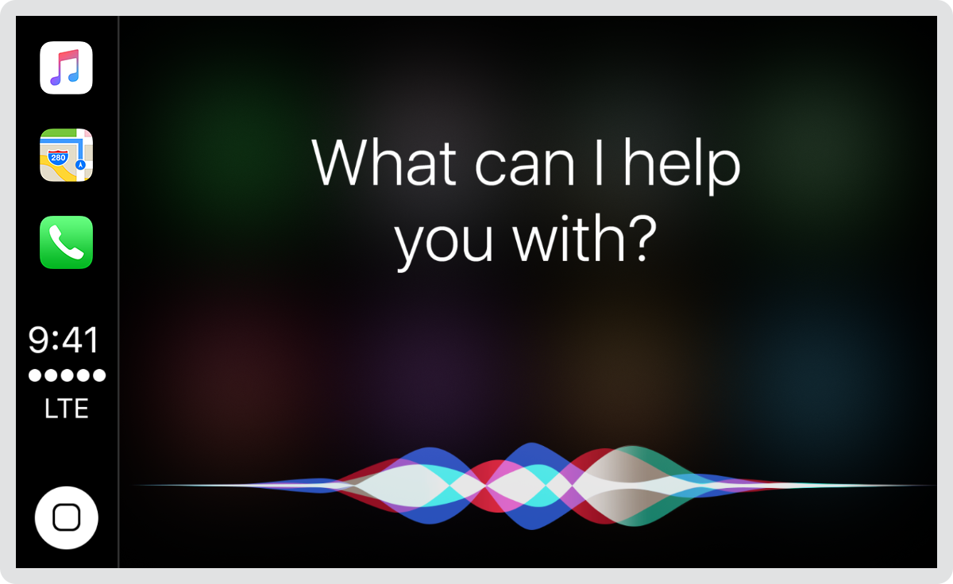

**Siri by IOS**

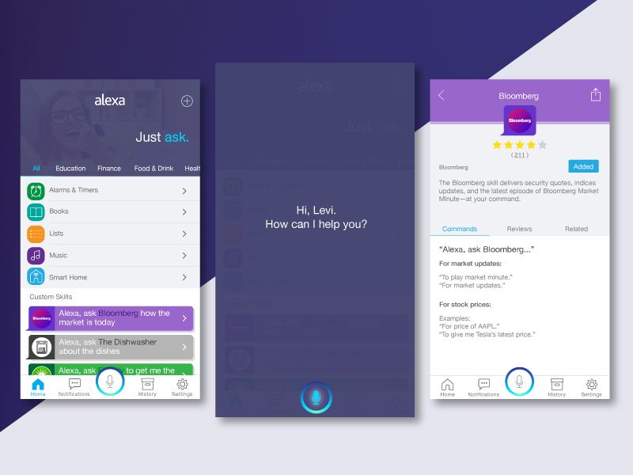

**Alexa by Amazon**

**Advantages of Personal Voice Assistant :**

* These applications make small and smart hand held devices to combine multiple features.
* They allow you to import and export data and also to transfer files from one device to other.
* Store various information about files and many other things in our devices.
* Make to do lists.
* Recognize voice commands.
* Controls various applications of devices.
* Provides services regarding your location.
* Helps to plan your own day.
* Reminds you important things on accurate situations or locations.
* Plays music and videos that we like
* Open games to play and some apps

**Disadvantages of Personal Voice Assistant :**

* Listening Problems
* Personal Assistant get problem to process wrong pronounced words and miscellaneous words.
* Silent mode support
* It gives response in voice output thus it doesn’t work properly in silent mode.
* Navigation Languages
* Most of the personal assistants can understand only English language.
* Internet access
* Artificial Assistant needs internet connection to give desired output for the user.
* Privacy and security
* Some assistants will be able to unlock or lock user devices by using voice recognizer. So, it will be unsafe for the users to turn on the voice recognizer.

**Personal Voice Assistants in future :**

1. Next step will be to strip back the physical hardware as far as possible to our next generation
2. With the intelligence of the Voice assistant existing in the cloud getting pulled in and pushing its way into our lives on multiple devices on our bodies and in our offices, homes, and vehicles.
3. Your Voice Assistant will be continuously prompting you with the suggestions and taking instructions and also will know more about you than perhaps you do yourself.
4. We can expect this device to be implanted and permanent on this mankind in future.

**Conclusion :**

Personal Voice Assistants are very effective way to organize your schedule. Now there are many Smart Personal Digital Applications available in market for various sevice platforms.

These new software applications are performing really well than PDA devices

as they provided with all resources of your own device. Personal Assistants are also more reliable than humans because they are more portable and you can use them anytime. They also have lot of information than any assistant as they are connected with internet.